**DEFINING THE ROLE OF OPERATIONAL SEX RATIO IN FITNESS OF ORGANISMS WITH SEXUALLY ANTAGONISTIC GENES**

An Undergraduate Research Scholars Thesis

by

R. DAVID GAFFORD-GABY

Submitted to the Undergraduate Research Scholars program at

Texas A&M University

in partial fulfillment of the requirements for the designation as an

UNDERGRADUATE RESEARCH SCHOLAR

Approved by Research Advisor: Dr. Heath Blackmon

May 2020

Major: Biology

TABLE OF CONTENTS

Page

ABSTRACT 1

Dedication 2

Acknowledgments 3

Nomenclature 4

chapter

1. IntroductioN 5
2. METHODS 7
3. Results 10
4. CONCLUSION 14

references 15

Abstract

Defining the Role of Operation Sex Ratio in Fitness of Organisms with Sexually Antagonistic Genes

R. David Gafford-Gaby

Department of Biology

Texas A&M University

Research Advisor: Dr. Heath Blackmon

Department of Biology

Texas A&M University

In many species, populations vary in size and reproductive sex ratio, producing situations in which small population sizes are paired with strongly skewed effective sex ratios. This imbalance among sexes is particularly important in populations with genes that experience different selective pressures in males and females. Understanding the role selection and drift play in such populations is important in determining the evolution of genetic variation and the role they play in the fitness of organisms. Using forward time population genetic simulations under various conditions, we show that certain conditions will lead to the fixation of genetic variation that benefits the more numerous sex and are deleterious to the rarer sex. These results suggest that in some species the rare sex may be destined to evolve lower fitness. This is of particular concern in cases where a species has a strong imbalance in the numbers of males and females and has reduced population size either due to domesticated production methods, climate change, or habitat loss.

Dedication

I would like to dedicate this to my parents, Lisa Gafford and Eugene Gaby. I could not have done this without their loving support. Thank you for raising me to have curiosity about the world around me and how it works.

Acknowledgements

I would like to thank by mentor and advisor, Dr. Heath Blackmon, for his tireless help during the course of this research, and his valuable advice, expertise, and suggestions during the course of this project. I would also like to thank Amy Shum for her contributions to this research project in the development of the models and simulations used.

Nomenclature

OSR Operational Sex Ratio

rd Recombination Distance

s Selection Coefficient

Chapter i

introduction

Natural selection and genetic drift are defining factors in the evolution of a species. However, the relative importance of drift and selection is a function of the population size of a species. When population size is very large, natural selection tends to be the dominant factor at work and beneficial alleles will increase in frequency in the population and deleterious alleles will decrease in frequency. In contrast, in smaller populations genetic drift will have a large impact on the fate of mutations. Beneficial alleles can be lost and deleterious alleles can increase in frequency both due to random sampling in a small population. This interaction between selection and genetic drift has been well documented in earlier empirical and theoretical works (Lande 1976; Allendorf 1986; Lande and Barrowdough 1987; Frankham 1996; Lacy 1997; Andrews 2010; Gerke *et al.* 2015; Perrier *et al.* 2017).

In addition to variations in population size, both natural and captive populations can experience variation in the ratio of sexes among reproductively active and capable organisms (Elmberg 1990; Gwynne 1990; Mitani *et al.* 1996; Jirotkul 1999). This ratio, known as operational sex ratio (OSR), can be skewed from a 1:1 balance by factors such as differential birth rates of sexes, different rates of survival to adulthood among sexes, and different fertility rates (Pitnick 1993; Faust and Thompson 2000; Hasselquist and Kempenaers 2002; Melfi 2012). However, the role of selection and drift in the presence of OSR and variable population size has not been investigated.

We hypothesize that this balance between selection and drift may extend below the level of a species to the sexes. This observation will have little bearing on genes that are essential for both sexes and have no allelic variation. However, for genes where one allele is favored in one sex and another is favored in the other sex, we expect the allele favored by the common sex to have a greater probability of fixation. This type of genetic variation, known as sexual antagonism, has been documented in as diverse species as red deer (*Cervus elaphus)* and fruit flies (*Drosophila melanogaster*) (Foerster *et al.* 2007; Innocenti and Morrow 2010)*.* Sexually antagonistic variation is also thought to be the driving force in the evolution of sex chromosomes and remodeling of chromosomes (Blackmon and Demuth 2015; Blackmon and Brandvain 2017). Evaluating the relationship between OSR, selection, and drift in variable population sizes can help us to better understand how sexually antagonistic variation evolves and influences the fitness of organisms across the tree of life.

In order to explore this relationship, we created forward time population genetic simulations with variable genetic architectures, OSRs, selection strengths, and population sizes. Our research shows that OSR indeed interacts with selection and drift to influence the fate of sexually antagonistic alleles within species.

Chapter ii

methods

In order to evaluate the dynamics of selection and drift within sexes in populations with sexually antagonistic alleles and variable operational sex ratios, we constructed diploid biallelic two-locus forward time population genetic models with non-overlapping generations and viability selection at each generation. One of the loci was the sex determining locus in an XY system. Heterozygous individuals were classified as male and homozygous individuals for the X allele were classified as female. The second locus was the sexually antagonistic locus. To capture the dynamics of sex chromosome evolution, it was linked to the sex-determining locus with a recombination distance of 20 centimorgans. To capture the dynamics of autosomal evolution, it was linked to the sex-determining locus with a recombination distance of 50 centimorgans. The recombination distance determines the probability of a recombination event during gametogenesis. When recombination distance is 50 centimorgans, the two loci will have a recombination event during gametogenesis half the time. This mimics the segregation of separate chromosomes. In contrast, when recombination distance is less than 50 centimorgans, alleles at these two loci are more likely to segregate together into gametes, matching our expectation for two loci on the same chromosome. The sexually antagonistic locus had two alleles (A1 and A2), where A1 is beneficial to males and A2 is beneficial to females. The fitness of each individual was determined by factoring in both the sex of the individual, as determined by the first locus, and the genotype of the second locus (Table 1).

We began simulations with a selected number of males and females. Once the common sex was defined, the number of the rare, or smaller, sex was determined using a ratio of the rare sex to common sex, called the OSR. Thus, in a population of 1000 males in which males are the common sex with an OSR of 0.5, there would be 500 females. In instances in which the OSR bias would result in a non-whole number integer value for the rare sex, the rare sex number was rounded up to the nearest whole number. Common sex population sizes were either 50, 100, 500, or 1000 with OSR bias ranging among 8 values (1.0, 0.8, 0.6, 0.4, 0.2. 0.1, 0.05). Thus, we evaluated results for 56 different pairings of numbers of males and females. For each of the population size and OSR parameters described, three dominance factors (0.0, 0.5, 1.0) were applied for the male benefiting alleles, where 0.0 represents a recessive allele, 0.5 represents an additive allele, and 1.0 represents a dominant allele. Each of these simulations was run at four different selection strength parameters (0.1, 0.2, 0.5, 0.9), resulting in a total of 768 unique scenarios. Each scenario was run 1000 times, with each run lasting for 1000 generations or until one of the sexually antagonistic alleles fixed in the population.

Table 1. Simulation fitness functions.

|  |  |  |
| --- | --- | --- |
| **Locus 2 Genotype** | **Male** | **Female** |
| A1A1 |  |  |
| A1A2 |  |  |
| A2A2 | 1 | 1 |

Note: In these functions, *h* represents the dominance factor and *s* represents the selection coefficient. Allele A1 is male beneficial and allele A2 is female beneficial.

At the start of each simulation run, the populations were set such that the A1 allele was at 50% frequency in both males and females and the alleles were assigned equally to X and Y chromosomes to avoid linkage disequilibrium. At the end of each generation, fitness of each individual in the population was assessed using the formulas set out in Table 1. On the basis of this fitness, females were randomly selected to contribute their gametes to the next generation, with the haplotype of the egg being selected randomly from each selected female. In males, a similar process occurred, differing only in allowing for recombination between the first and second locus in the sperm haplotype selection process. The recombination that was allowed in males was a function of the genetic distance of the first and second loci (rd) as described previously. This was necessary for males as the male sex determining locus genotype is heterozygous, but unnecessary for females because the female sex determining locus is homozygous. To generate the next generation, selected eggs were paired with randomly selected sperm containing the appropriate sex determining allele (X or Y) to maintain an OSR and population size as prescribed by the scenario’s population parameters. This process was repeated for each generation until the simulation ended, either by reaching 1000 generations or by one allele fixing in the population. In some instances, the results were better understood in terms of effective population size (Ne) rather than true population, which we calculated using the standard formula for variance effective population size in populations with unequal sex ratio (Equation 1).

$N_{e}=\frac{4N_{c}N_{r}}{N_{c}+N_{r}}$ (1)

Where $N_{c}$ is the number of the common sex and $N_{r}$ is the number of the rare sex.

Chapter III

Results

The results of our simulations demonstrate clear “danger zones” in which selection predominantly acts on the common sex and drift acts primarily in the rare sex, resulting in a tendency towards fixation of alleles beneficial to the common sex and a collapse in fitness in the rare sex. Whether the common sex benefiting allele was dominant, recessive, or additive in a scenario influenced the degree to which the common sex benefiting allele fixed. Scenarios in which the allele benefitting the common sex was recessive resulted in the highest rates of fixation for that allele, and scenarios in which that same allele was dominant yielded the lowest rates of fixation for that allele. Intermediate levels of fixation of the allele benefitting the common sex were observed when that allele was additive. This effect is most striking in cases where the Ne was between 500 and 1000 (Figure 1).

Simulations set with 1000 individuals of the common sex and an OSR of 0.05 fixed the allele beneficial to the common sex between 2 and 26% of the time across genetic architectures. At large common sex population sizes and across all genetic architectures, higher OSRs tended to result in both alleles being maintained throughout the simulation. When the common sex population size is reduced to 500 individuals and the OSR is either 0.10 or 0.05, the common sex benefiting allele fixed between 2-27% and 40-98% of the simulations, respectively. However, the most dramatic collapses in fitness in the rare sex can be seen when the common sex population size is reduced to 100. Under this situation, we found high rates of fixation of the alleles benefitting the common sex across scenarios with various OSR values and genetic architectures. The most extreme examples of this pattern under this population size scenario is found when the OSR values are either 0.10 or 0.20, in which the fixation rates for the allele benefiting the common sex approaches 100%.

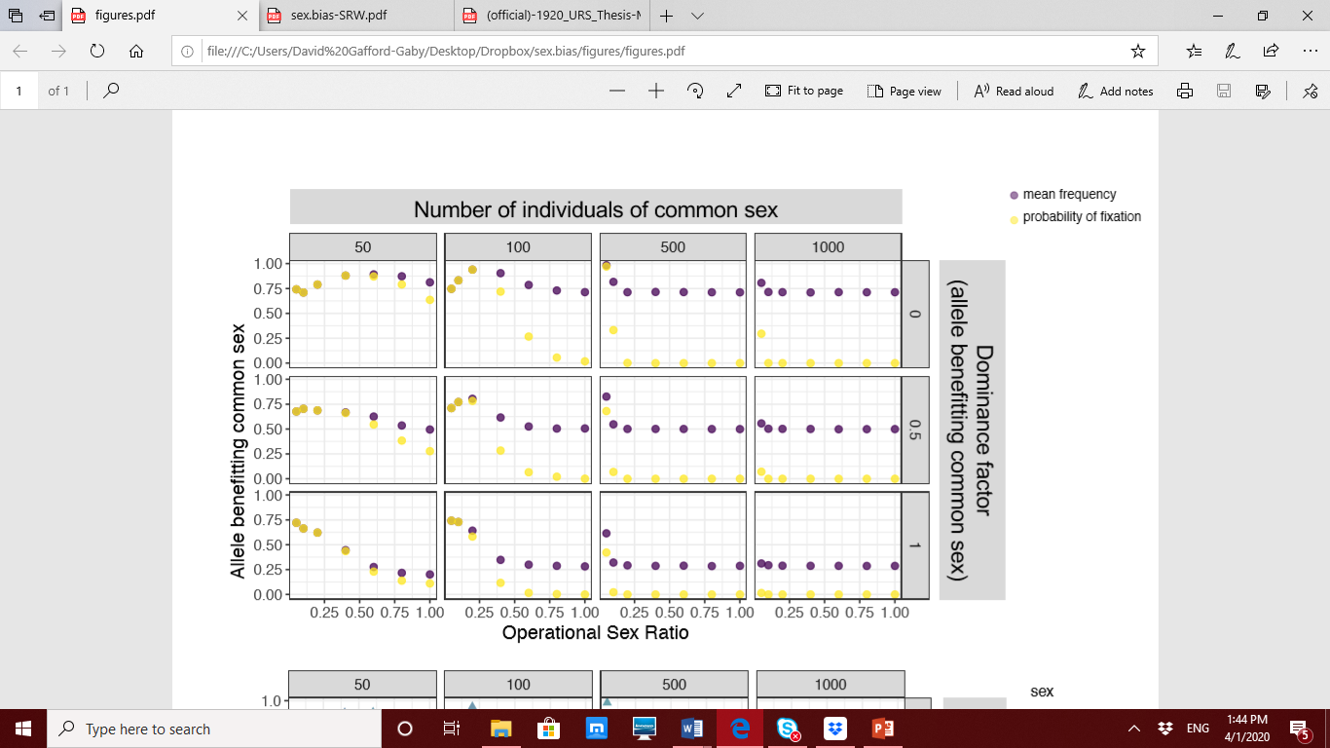

Figure 1: Impact of variation in operational sex ratio on genetic variation. Columns indicate number of individuals of the common sex, while rows indicate the dominance factor. The x-axis represents the operational sex ratio. The y-axis represents either the mean frequency of the allele benefitting the common sex (yellow) or the probability of that allele fixing (purple).

Reducing the common sex population size to 50 individuals allowed genetic drift to predominate, and a high degree of fixation was observed even with equal numbers of both sexes participating in reproduction. With an OSR of 1.0 and an additive genetic architecture, one of the two alleles fixed in 25% of the simulations. However, under a similar scenario but with a recessive common sex benefiting allele, that allele fixed nearly 60% of the time. Likewise, when this scenario was set with the allele benefitting the common sex displaying a dominant genetic architecture, the rare sex beneficial allele fixed in 60% of the simulations. This latter scenario is the only parameter set that consistently resulted in an overall higher degree of fitness for the rare sex. Despite this, we would expect that an equal number of mutations in the dominant genetic architecture would balance this, resulting in no net gain in fitness for the rare sex. Furthermore, scenarios with these conditions but with an OSR reduced below 1.0 begin to display bias for fixing allele benefitting the common sex once again.

There is no evidence or reason to believe that male or female beneficial mutations should be biased towards specific genetic architectures. Therefore, we can safely marginalize across genetic architectures to analyze the mean difference between common sex and rare sex fitness. From this, we show that when the common sex population is small (either 50 or 100 individuals), unequal OSR values, those less than 1.0, lead to a decrease in the rare sex’s fitness relative to the common sex, and the decay of the rare sex’s fitness becomes most pronounced when OSR levels are less than 0.5 (Figure 2). However, larger common sex population sizes require a higher OSR level (0.05-0.10) to drive a collapse of the rare sex fitness. The most extreme rare sex fitness collapse that we documented was for the case of a common sex number of 500 and an OSR of 0.01. This most extreme case best demonstrates the validity of our hypothesis that the fate of alleles can be driven by the selection coefficient in a single sex when OSR is extreme. If we look back to Figure 1, we see that under these conditions the mean allele frequency of the allele that benefits the common sex is significantly elevated from the equilibrium expectation for an OSR of 1. Furthermore, these populations often fix the allele that benefits the common sex (40-98% of simulations).

Though our results are described in terms of an XY system, they apply equally in a ZW system if X and Y are exchanged with Z and W and males and females are exchanged. Results for autosomal loci would also apply to all genes in a species with environmental sex determination systems. The latter is of increasing relevance as climate change could produce consistent strong biases in sex ratio in organisms with temperature based environmental sex determination, which in turn could put such populations at risk for rare sex fitness collapse.

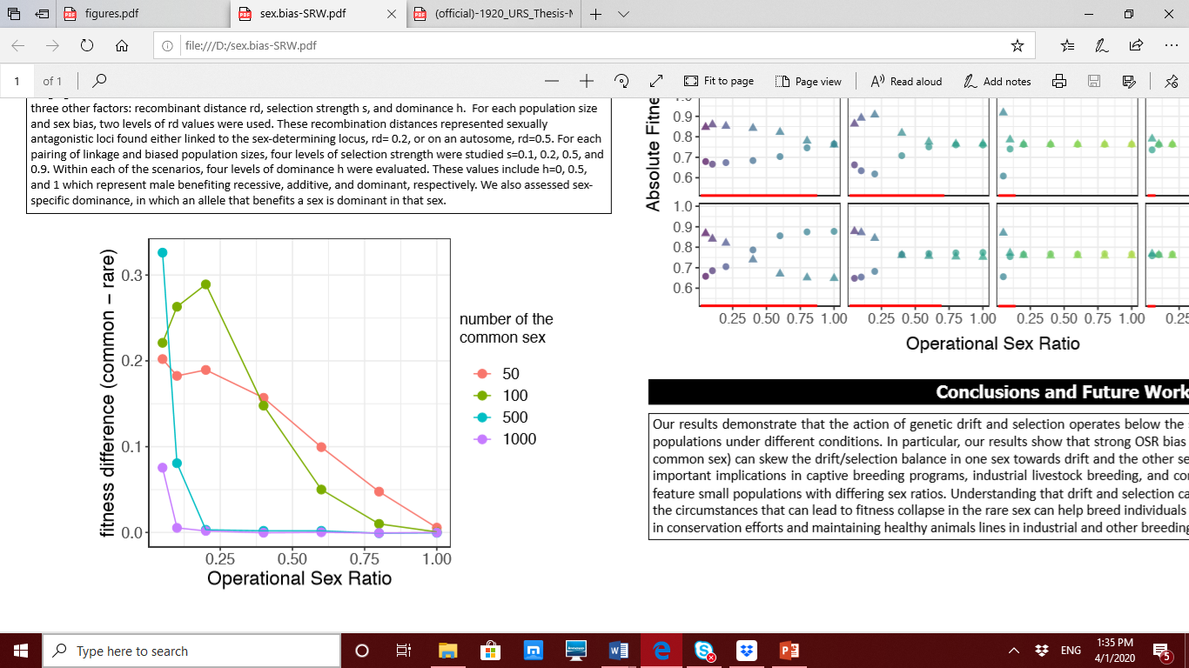

Figure 2: Fitness divergence among sexes. The y-axis represents the difference between the absolute fitness of the common sex and that of the rare sex. The x-axis represents the operational sex ratio. These results are for a sexually antagonistic locus linked to the sex determination region (rd=0.3) with an s, or selection coefficient, of 0.5. The color of the line represents the number of the common sex. Higher values on the vertical axis indicate increased fitness for the common sex and reduced fitness for the rare sex.

Chapter IV

Conclusion

Our results demonstrate that the action of genetic drift and selection operates below the species level and can vary among the sexes. In particular, our results show that strong OSR bias and small population size (100 individuals in the common sex) can lead to the fate of an allele being determined by the selection coefficient in a single sex such that if an allele is favored strongly in the common sex it can fix even when it is equally deleterious to the rare sex. Our results have important implications in captive breeding programs, industrial livestock breeding, and conservation efforts, as these programs frequently feature small populations with extreme sex ratios. Understanding that drift and selection can work within sexes of a species and knowing the circumstances that can lead to fitness collapse in the rare sex can help breed individuals that retain alleles beneficial to both sexes, aiding in conservation efforts and maintaining healthy animal lines in industry and science.

References

Allendorf, F. W., 1986 Genetic drift and the loss of alleles versus heterozygosity. Zoo biology 5**:** 181-190.

Andrews, C., 2010 Natural Selection. Genetic Drift and Gene Flow do Not Act in Isolation in Natural Populations. Nature Education Knowledge 3**:** 5.

Blackmon, H., and Y. Brandvain, 2017 Long-term fragility of Y chromosomes is dominated by short-term resolution of sexual antagonism. Genetics 207**:** 1621-1629.

Blackmon, H., and J. P. Demuth, 2015 Genomic origins of insect sex chromosomes. Current Opinion in Insect Science 7**:** 45-50.

Elmberg, J., 1990 Long-term survival, length of breeding season, and operational sex ratio in a boreal population of common frogs, Rana temporaria L. Canadian Journal of Zoology 68**:** 121-127.

Faust, L. J., and S. D. Thompson, 2000 Birth sex ratio in captive mammals: patterns, biases, and the implications for management and conservation. Zoo Biology: Published in affiliation with the American Zoo and Aquarium Association 19**:** 11-25.

Foerster, K., T. Coulson, B. C. Sheldon, J. M. Pemberton, T. H. Clutton-Brock *et al.*, 2007 Sexually antagonistic genetic variation for fitness in red deer. Nature 447**:** 1107-1110.

Frankham, R., 1996 Relationship of genetic variation to population size in wildlife. Conservation biology 10**:** 1500-1508.

Gerke, J. P., J. W. Edwards, K. E. Guill, J. Ross-Ibarra and M. D. McMullen, 2015 The genomic impacts of drift and selection for hybrid performance in maize. Genetics 201**:** 1201-1211.

Gwynne, D. T., 1990 Testing parental investment and the control of sexual selection in katydids: the operational sex ratio. The American Naturalist 136**:** 474-484.

Hasselquist, D., and B. Kempenaers, 2002 Parental care and adaptive brood sex ratio manipulation in birds. Philosophical Transactions of the Royal Society of London. Series B: Biological Sciences 357**:** 363-372.

Innocenti, P., and E. H. Morrow, 2010 The sexually antagonistic genes of Drosophila melanogaster. PLoS biology 8.

Jirotkul, M., 1999 Operational sex ratio influences female preference and male–male competition in guppies. Animal Behaviour 58**:** 287-294.

Lacy, R. C., 1997 Importance of genetic variation to the viability of mammalian populations. Journal of Mammalogy 78**:** 320-335.

Lande, R., 1976 Natural selection and random genetic drift in phenotypic evolution. Evolution 30**:** 314-334.

Lande, R., and G. Barrowdough, 1987 Effective population size, genetic variation, and their use in population. Viable populations for conservation**:** 87.

Melfi, V., 2012 Ex situ gibbon conservation: status, management and birth sex ratios. International Zoo Yearbook 46**:** 241-251.

Mitani, J. C., J. Gros-Louis and A. F. Richards, 1996 Sexual dimorphism, the operational sex ratio, and the intensity of male competition in polygynous primates. The American Naturalist 147**:** 966-980.

Perrier, C., A. L. Ferchaud, P. Sirois, I. Thibault and L. Bernatchez, 2017 Do genetic drift and accumulation of deleterious mutations preclude adaptation? Empirical investigation using RAD seq in a northern lacustrine fish. Molecular ecology 26**:** 6317-6335.

Pitnick, S., 1993 Operational sex ratios and sperm limitation in populations of Drosophila pachea. Behavioral Ecology and Sociobiology 33**:** 383-391.